Sensor based Lighting.

<IMAGEN SUPERIOR PARA EL PAPER>

Abstract
Commonly used global illumination techniques have good quality but are computationally expensive and difficult to parallelize in GPU. We propose a novel global illumination algorithm that locates virtual cameras called sensors in many visible pixel of the scene. Each sensor captures the incoming light from all light sources of the scenes and produce and estimation value that is later compose with the original image. The algorithm is an offline solution implemented in GPU in a very parallelizable way, supports arbitrary-form light sources, and produces soft shadows, ambient occlusion and color bleeding effects.
CONTINUAR UN POCO MAS

Introduction
Many techniques used in computer graphics to simulate lighting effects are based on source lights called point-lights. They are fast to compute and easy to integrate in a real-time graphics pipeline.
But real life lighting appliances are normally design to avoid direct lighting because it’s uncomfortable for the human eye. For example, a table lamp came usually covered by a surface that produces a glimmering light in the room. Sun light entering a building through a window with curtains behaves like a large superficial light source.
These arbitrary-form light sources behave in a very different way of commonly used point lights, for example when generating soft shadows with complex penumbra area.
Furthermore, in a closed room, the light coming from different light sources will bounce against many surfaces before finally reaching the eye. En each of this bounces part of the energy is absorbed and another part is reflected in certain wave length, according to the BRDF [1] distribution. The human eye is particularly sensitive to this kind of indirect illumination. This way, a red wall may transfer some of its color to a white ceiling, producing a reddish look, known a color bleeding.
The energy transported from de light source quickly reaches a thermal equilibrium. So, as long as the scene stays static, the image is stable. Every point receives light coming not only from de light sources but also from the rest of the scene. This is known as ambient light and produces a very dim light, which is quickly recognized by the human eye, usually in walls and ceiling corners of a room.
The aim of this paper is to present an offline algorithm implemented in GPU that supports all this subtle effects, from a physically based perspective: an algorithm capable of modeling a large amount of arbitrary-form source lights, and capable of producing physically correct soft shadows, besides able to approximate another aspects of global illumination, like color bleeding and ambient occlusion.

Related work
Many algorithms have been developed to generate realistic images based on global illumination models. Path tracing [2] and Metropolis Light Transport [3] are examples that used random sampling to estimate a solution that converge to a physical correct result. But they tend to required thousands of samples per pixel in order to achieved good results, which makes them computationally expensive.
Radiosity, a finite based element solution, also converges to a physically correct solution with an iterative procedure. It is also a computationally expensive and it requires the scene to be fairly tessellated. Furthermore only models diffuse reflections in such a way to be usually mixed with others techniques to support specular light.
All techniques mentioned below has the objective to produce a physically correct image regardless of the time required to be computed.
On the other side, there are algorithms acutely fast to be used in real-time applications. They can compute direct shadows (shadow map [5], volume shadows [6]) and ambient light (ambient occlusion [7]) in a very simplified form. These techniques are usually known as to be perceptually correct but physically incorrect. This means that although they are not accurate in physics terms they can be visually attractive to the human eye.
Many methods exist to also produce soft shadows perceptually correct, like Variance Shadow Maps [5] and Cascaded Shadow Maps [6].
In many situations such physical precision is not required and some error degree can be tolerated in order to speed up the computation.

Sensor based Lighting

Algorithm overview
The presented algorithm can be seen as an intermediate solution between a physically precise method based on radiosity and a perceptually correct one based on Shadow Maps. The technique presented in this work consists in positioning virtual cameras in many visible points of the scene. These cameras act like sensors that measure the amount of incoming light from all directions. In order to achieve that, each camera draws the complete scene in an auxiliary texture. The texture's size is big enough to get every illumination details, and then is reduced to unique average value which represents the light received from the entire scene. This value is stored in an output texture used later to draw the final scene.

<IMAGEN 1>

Figure XXX: census function. The light coming from the scene is captured by the top right sensor in the first image. The sensor's image is then weighted by its incident angle and the BRDF function, and the last step is to average the final color.

Visible points determination
Unlike others finite elements based techniques, for example Radiosity [CITAR], this algorithm resolves each visible point in only one step. It does not require to storage intermediate values and successive refinement passes. Moreover it is not necessary to create heavily tessellated meshes (called patches) in order to achieved good results. The algorithm can work directly from the each point of the scene.
However the solution is only useful for one point of view. It is targeted to create a photo-realistic image and not a video or interactive animation.
The first step consists of creating a geometry buffer (G-buffer CITAR) to store some useful information of the visible points of the scene:

G(i,j) = { p, n, id }

p = position = (x,y,z)
n = normal = (nx,ny,nz)
id = polygon or mesh id

Different packing strategies derived from the deferred rendering techniques (CITAR) can be used to create this G-buffer.
Radiometry equations
The rendering equation brings a complete description of the light transport among all surfaces of a scene when this one has achieved a steady state. All different rendering techniques try to resolve this equation in some way or another.

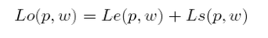
Outgoing radiance = Emitted Radiance + Scattered Radiance

The term Le forms part of the scene description and correspond to the light sources, which are the only objects that emit light. The second part of the equation, the scattering equation, is of more significant for this work:

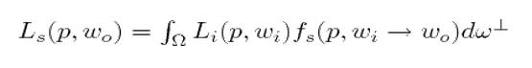

Where wo is the view direction, wi the inconming direction, dw´ is the differential projected solid angle and the integral is made all over the positive hemisphere above the surface. The scattering equation (Ls) can be used to predict the surface color from the incident light. Our work applies this principle to adapt the equation to a GPU suitable computation.
Li (ingoing radiance) can be expressed in terms of Lo (outgoing radiance):

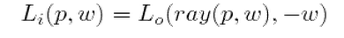
ray(p,w) is a ray casting function which returns the intersection point between the ray p+k.w and the scene. Lo appears in both sides of the equation, forming a recursive expression.
The scattering equation can be used to predict the surface color from the incident light. This paper applies this principle to adapt the equation to a GPU suitable computation.
Outgoing radiance estimation
The strategy of this work is to replace Lo by an estimator to avoid the recursive form of the scattering equation. Considering a fixed point p then two situations must be studied:

A- if p is over the surface of a light source Le (emitted radiance) it will have a value corresponding to the color emitted by that light, an information that forms part of the scene. We can assume that this value is highly to Ls for a light source. So then we can express:

Lo = Le (1)

B- if p is over a surface that reflects light, Lo is described by the scattering equation, then its value depends on the light coming from all directions of the hemisphere. In this case the surface diffuse color (also part of the scene description) is taken as an estimation of the value, multiplied by an epsilon:

Lo = D . e (2)

The epsilon term is a small number that allow setting the importance of the ambient light related to the direct light. And it represents the fact that the incident light is reflected in all directions, so the amount of light reflected in one particular direction is very small compared to the sum of light coming from another particular direction:

For example, the incident light may have come directly from a light source or from another reflective surface. But in each step one part of the incident light is absorbed by the surface and the other part is reflected in all directions, following the fs distribution (BRDF). Regardless the case of a perfect mirror, the resulting light will always have much less energy than the incident one.
Taking the surface color for Lo may seem a gross estimation. But this color is multiplied by a very small value and these values of Lo are then integrated over the whole hemisphere to obtain only one final result of Ls.
So the Lo estimator is expresses as:

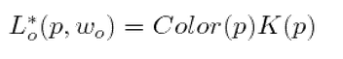
The estimator groups together (1) and (2) in the same equation. From a computing point of view the difference between (1) and (2) is just the specific value of K(p). In one case is the light associated energy and in the other is a small epsilon. But from physical point of view the two cases correspond to totally different processes. It is important to note that the calculated values may take a wide range of results. So the precision of a high dynamic range (CITAR) is required.
This document abbreviate the term Color(p)K(p) as CK. Replacing this term in the scattering equation we get:

Scattered radiance estimation

The last integral can be approximated by the following summation:
(3)

In this equation, the differential projected solid angle is replaced by the equivalent expression:

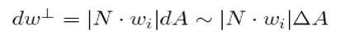
Whew delta A represents the area occupied by the solid angle which is then projected over the tangent space (Nusselt analog CITAR).

Sensor

In this algorithm a sensor represents a virtual camera that allows us to capture the incoming light from all directions of the scene. This light is then stored in texture named radiance map (R), that represent the sensor area. The camera is located at the required point p in the direction normal to the surface of the scene.
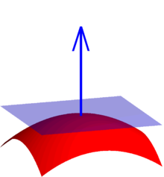
Figure XXX: COMPLETAR

The R texture size is rdx x rdy and each texel represent a sample of the CK term for given direction in space. The R's values represent the result of sensing p and are used to approximate the equation (3). So the sensor is applied to compute the CK term for a large quantity of samples and then to use them in the equation (3).
In order to be able to capture the scene illumination from most posible angles, the camera field of view (fov) is of 135 degrees (which amplitude is higher than the 45 degrees commonly used). This brings out two main problems. Fistly, such a high value in fov amplitude tends to loose precision at the center of the image, just where the samples have more incidence. Secondly, we can never take a sample of 180 degrees of amplitude using a perspective or orthogonal projection. This means the sensor is incapable of capturing the light coming from angles out of the fov (for example from 0 to 45). This aspect is by far the biggest source of the estimation error. However those angles are the ones who have the fewer incidences in the equation (3), because the terms are multiplied by the cosine of the angle between the incident ray and the surface normal of the point.
The CK term for a giving pixel, drawn from the sensor point of view, can be computed using a Pixel Shader in GPU because both Color and K are part of the scene description. Te original summation over the amount of samples is replaced by a double summation to iterate over the values of R in width and height. Given:

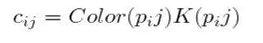
Arreglar el subinidce de la formula, la j minuscula
The cij value is stored in R. The BRDF function:
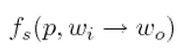
Represents the amount of radiance coming from the wi direction that reflects towards the wo direction. Given that wo is fixed for a determined image (wo is the view direction) then function only depends on wi, the point p and the surface. In the simplest case the function can be constant and the term fs becomes a proportional constant less equals to 1/pi (from the integral of (3)). Normally this constant factor is absorbed in other constants terms of the algorithm.
The remaining part of the equation is the (4) term:

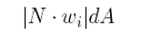
As we mentioned before this term represents the surface of the projected solid angle over the tangent space.
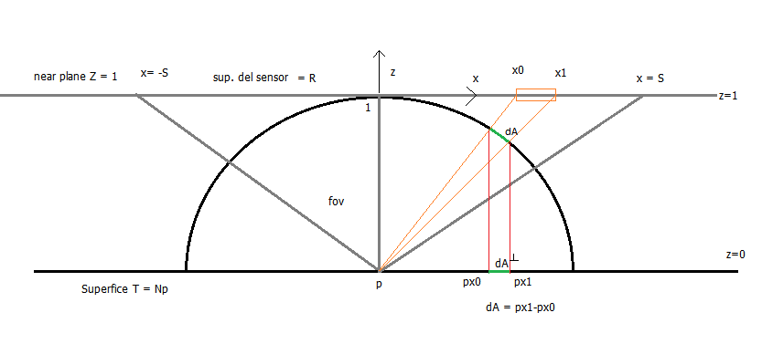
Given a sample (i, j) in the sensor area (R), the goal is to find the value of dA which corresponds to the projected area over the tangent space (T). R has a size of rdx x rdy samples. The size of the pixel is first projected over the hemisphere and then over T.
As we can see in image XXXX:

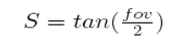
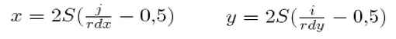
Given (px, py) = the projection of p over the surface sensor, then:
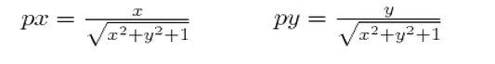
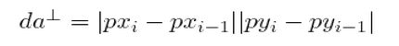(5)

The value (5) represents the pixel projection over the tangent space in arbitrary pixel units. The sum of the area of all possible angles is equal to the whole disc surface hemisphere, which equals pi. So the relative value of each sample (without units) is:

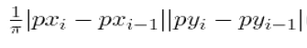
The total area of the samples can be calculated as rdx x rdy, which allows us to approximate the term (4) with:
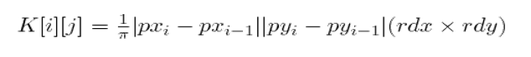
With this formulation, the energy values associated with each source light must be set in [radiance units] x pixel.
As can be seen the Kij values only depend on i and j, so they can be pre computed. The physical interpretation means that the light coming from similar directions to the normal has the max incidence over sensed value, while the peripheral directions decreased rapidly.
The estimated scattering equation becomes:
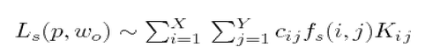
This value is the one obtained as a result in each sensor and then stored in the output texture called radiance map.
Shadow computing
The size of the area of the sensor (rdx x rdy) must be large enough to capture all the details from the light sources. An area too small may generate discontinuities in the estimation of Ls which will be perceived as noise in the image.
The objective of the algorithm is to assign enough pixel area for each light source in the sensor, in order to obtain a good estimation of Li. Favourably, for superficial light sources, or for large enough arbitrary forms, this estimation can be extremely accurate when the proper texture size is given. This is due to the fact that the projection of the light source over the sensor area occupies a large amount of samples. So the sensor is very sensitive to obstacles that may block part of it, producing physically correct shadow penumbras.

<IMAGEN REGIONES SOMBRA>

Figure XXX: shadow computing. The red rectangle represents sensed area. The first screenshot shows the light source totally visible. Then, the visible area of the same gradually decreases as the shadow becomes more evident in the final image. In the fourth screenshot the light source is no longer visible and the area is completely in shadows.
It is useful to study the optimal size of the sensor area. The bigger the area size the lower the variance in the solution, but with an increased overhead in rasterization. However the relation is not lineal. If we increase the area size twice as much, the rendering time does not increase that much and the variance does not reduce to half its value. Many others factors intervene in the process and ultimately it depends on the size of the light sources. The bigger the lights the lower the size required to reduce the noise of the solution.

<IMAGEN 4 figuras>

Figure XXXX: the sensor area. Left: a 32x32 pixels sensor. Note the noise on the floor and the left wall.
Sensor quantity and distribution
In many parts of the domain the value of Ls changes in a soft way. Except when there is a change of surfaces, it is very likely that Ls will be continuous in the point neighborhood. Even if it changes from an illuminated point to another in shadows on the same surface, the difference should be continuous. This suggests that it is not necessary to compute Ls in all the image points. The algorithm can being sensing at regular intervals from a given tile of dt x dt. Each tile will have a sample to which Ls is estimated. Then for each sample it computes the variation with the two closer samples. If this variation is less than a given threshold, called dradiance, the whole set can be estimated with lineal interpolation (similar to bilinear sampling [CITAR]). By the contrary if the variation is greater than dradiance then more samples may be located in tiles of half the size of the initial interval (dt / 2). The process is repeated until only final pixels are left, where Ls is computed specifically to complete the scene.
In this way the algorithm converge to the solution in a progressive way, using more sensors where the image needs them most.

<IMAGEN COMPUTE PROGRESIVO 1>

Figure XXXX: The red samples have little variation between them and can be interpolated to drastically reduce the amount of sensing operations. The white samples however have an abrupt change and require more samples.

<IMAGEN COMPUTE PROGRESIVO 2>

Figure XXX: tiles progressive computation. The first image shows tiles of 16 x 16 pixels. Only one sample per tiles is computed which value is interpolated between the neighborhood samples. In the next steps the tile size is reduced. At the end only the edge pixels remain to be sensed, where Ls is discontinuous.

This method allows us to reduce the total rendering time up to 80%. The initial tile size and the threshold dradiance are the parameters to be studied that will further optimize the technique. A high value for both parameters will produce a noise image with discontinuous blocks.

Final image composition
So far we have generated a map of values for Ls for each visible point of the scene, which are stored in the radiance map. Each value is called R(x, y). Next, the texture is combined with the original image in order to produce the final image. For a given point (x,y) of the original image, the same point of the radiance map contains the value of Ls. Both values are multiplied:
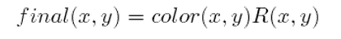

The tile optimization of the algorithm tends to produce small discrete blocks in the final image, an aliasing normally seen in most sampling techniques that use regular intervals. Replacing the regular sampling by a random one (for example with jittering techniques) will transform those aliasing in noise, and the visible artifacts will be appreciable. A better solution is to apply a Gaussian filter to image composition. A certain radius of samples of the radiance map is taken, provided that they belong to the same surface. This restriction is vital in order to avoid summing values of Ls coming from different regions of space, which will produce hard artifacts in the solution. That’s why the G-Buffer stored the polygon id.

kij is the relative weight of each sample and is computed considering the total amount of samples that satisfied the surface id condition (that is they belong to the same polygon as the point (x, y))
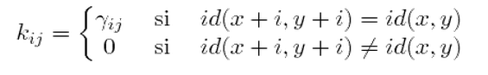
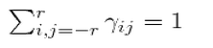

<IMAGEN Filtro Gauss>

Figure XXX: Gaussian filter application in image composition. Note that the red surface edge (wall) and the gray one (floor) continue to be sharp. The filter is specifically design to preserve the id sudden changes.

Implementation and Results
PENDIENTE
CPU:Intel(R) CORE (TM)i7 - 3770k CPU @ 3,50GH 3,90 GH
RAM: 16 GB
SO: Windows 7 Ultimate de 64 bits
Placa: NVIDIA GIFORCE GTX 660 (TI) Integrated RAMDAC 4095MB
Shader model 3.0 DX9

Conclusions
The algorithm presented provides an alternate method to solve the global illumination of scene, with support for complex effects like arbitrary-form of light sources, soft shadows, ambient occlusion and color bleeding. The solution is designed to be computed in GPU, taking advantage of many hardware accelerated features. Only one pass is required and it does not need to store any intermediate value, which makes it a highly parallelizable solution. Only a minimal synchronization is required at the end of each tile pass in order to interpolate the values.
The final image obtained by the method has a very realistic looking and it requires relative less processing time than many Ray-Tracing based solutions [3] solutions.
Unlike Radiosity [4] it is not required to heavily tessellate the scene, which represents one of the drawbacks of that technique. The original scene data can directly be used by the algorithm.
Furthermore the algorithm has a progressive nature, allowing the user to preview the final image before the rendering process has completely finished.

Future work
The technique is in its early stages. Further studies for optimization are required in order to achieve the performance and scalability of professional rendering solutions.
Its main problems are produced by the limited angle of fov used by the sensor, which avoids the algorithm to capture the illumination from certain angles. The problem could be solved by using ray tracing directed to the light sources so as to estimate a statistical value of visibility degree for that light source in the problematic angles. Few rays should be needed so the performance of the solution should not be overly affected.
Another drawback of the algorithm is that it does not scale well in relation to the scene complexity. A small increase in the time needed to render only one snapshot will be multiplied by hundreds of snapshot needed to compute the entire scene. Furthermore a complex geometry (for example a heavy tessellated mesh) produces a considerable overhead in the GPU computation, and it may probably not contribute too much to the final image.
This suggests a branch of investigation to study process for mesh simplification but not directed by a geometry heuristics, but for a light conservative criterion. A scene voxelization algorithm [CITAR] may take advantage of this principle.
Point light sources may suffer for a too high variance between sensors. To minimize this variance an auxiliary visibility function may be added, returning one if the source is visible from the point or returning cero if it is not. Then the light could be drawn like a superficial source, like a sphere of a given size that guaranteed its projection in many pixels. The color of the source should be a key value, and the sensor computation should check this color key to determine the visibility factor.
Others arbitrary forms of BRDF could be easily incorporated in the solution replacing the constant factor by a mixed equation. This equation may contemplate diffuse surfaces and some partially glossy mirrors surface. Perfect mirrors would be problematic because the variance of the solution would produce too much noise in the image. Others techniques suit better for this kind of surfaces.

References
[1] Physically Based Rendering.
Math Pharr – Grez Humphreys.
P284.

[2] Kajiya, J. T. 1986. The rendering equation. In Proceedings of the 13th Annual Conference on Computer Graphics and Interactive Techniques. D. C. Evans and R. J. Athay, Eds. SIGGRAPH '86. ACM, New York, NY, 143-150.

[3] Metropolis Light Transport by Eric Veach , Leonidas J. Guibas
Computer Graphics (SIGGRAPH '97 Proceedings)

[4] radiosity
http://www.siggraph.org/education/materials/HyperGraph/radiosity/overview_1.htm

[5] L. Williams: Casting curved shadows on curved surfaces. SIGGRAPH Comput. Graph., vol. 12, nº 3, pp. 270-274, (1978).

[6] E. Eisemann, M. Wimmer, U. Assarsson y M. Schwartz, Real-Time Shadows, Taylor & Francis, (2011)

[8] Real-time Rendering. Akenine-Moller. Eric Haines. Naty Hoffman.
P373

[9] ROBUST MONTE CARLO METHODS FOR LIGHT TRANSPORT SIMULATION. Eric Veach [1987]
P112 , P116

[10]American National Standards Institute [1986]. ANSI standard nomenclature and definitions for illuminating engineering,, ANSI/IES RP-16-1986, Illuminating Engineering Society,
345 East 47th Street, New York, NY 10017.

[11] The Nusselt Analog http://www.siggraph.org/education/materials/HyperGraph/radiosity/overview_2.htm

[12] Radiometric integrals
http://www.cmpe.boun.edu.tr/courses/cmpe535/spring2010/brdfandintegralsavs.pdf

FORMULAS

[Faltan métricas]

Lista de ecuaciones

Outgoing radiance
Lo(p,w) = Le(p,w) + Ls(p,w)

Scattering radiance
L_s(p,w_o) = \int_ \Omega L_i(p,w_i)f_s(p,w_i\rightarrow w_o)d\omega^\perp

Ingoing radiance
L_i(p,w) = L_o(ray(x,w), -w)

Diferencial del solid angle proyected
dw^\perp = \left |{w_i\cdot{N}}\right |dw

Sin nombre
L_o(p,w_o\rightarrow w_i) = L_i(p,w_i) f_s(w_i\rightarrow w_o) << L_i(p,w_i)

Estimador Lo
L_o^*(p,w_o) = Color(p) K(p)

Varias:
L_s(p,w_o) = \int_ \Omega Color(p) K(p)f_s(p,w_i\rightarrow w_o)d\omega^\perp
L_s(p,w_o) \sim \sum_{t=1}^n{} Color(p_t) K(p_t)f_s(p_t,w_i\rightarrow w_o) |N\cdot w_i| \Delta A
L_s(p,w_o) \sim \sum_{i=1}^X{} \sum_{j=1}^Y{} c_i_j f_s(i,j) K_i_j

S = tan(fov/2) → S = tan(\frac{fov}{2})

x = (j/ rdx - 0.5)*2*S → x = 2S(\frac{j}{rdx} - 0.5)

px = x/ sqrt(x*x + y*y + 1) → px = \frac{x}{\sqrt[2]{x^2 + y^2 + 1}}

dxi = |pxi-pxi-1|
\Delta A = |px_i-px_{i-1}||py_i-py_{i-1}|

dxi * dyi / pi

K[i][j] = (dxi * dyi / pi) * (rdx x rdy)
K[i][j] = \frac{1}{\pi }|px_i-px_{i-1}||py_i-py_{i-1}| ( rdx\times{}rdy)

final(x,y) = color(x,y)[ \sum_{i=-r}^r{ \sum_{j=-r}^r{k_{ij}Ls(x+i,y+j)}}]

k_{ij}=\begin{Bmatrix} \gamma_{ij} & \mbox{ si }& id(x+i,y+i)=id(x,y)\\0 & \mbox{si}& id(x+i,y+i)\neq id(x,y)\end{matrix}

\sum_{i,j=-r}^r{ \gamma_{ij} = 1

